Brian Santana

Linux Administration

**Lab 5 Continue Setup**

**CentOs**

To check the repolist you would type in yum repolist to add a repolist type in yum install cowsay or a github repository link would also work

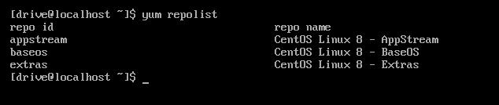

**Tmux**

To Install tmux you enter sudo yum Install tmux

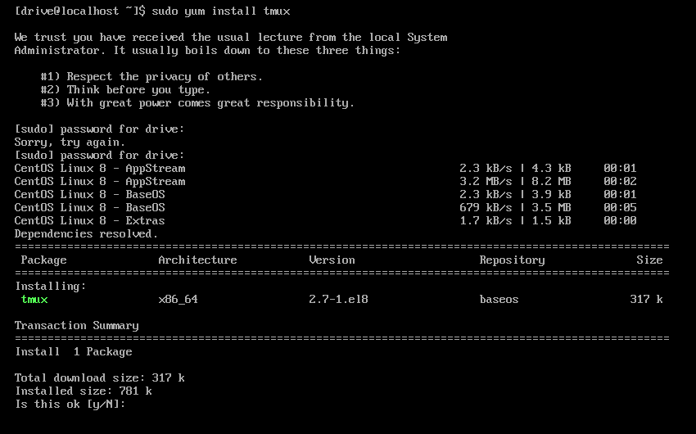

Afterwards you will be asked if you wish to install it with a yes or no prompt hit y

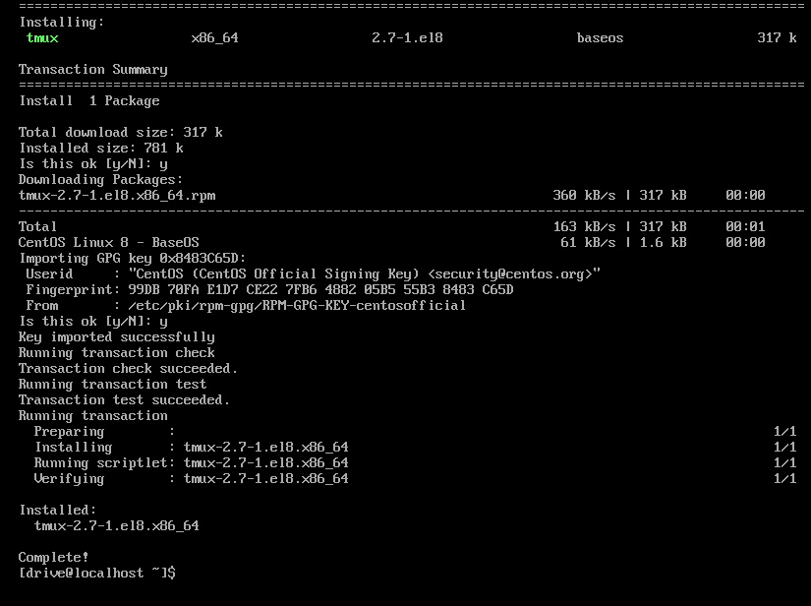

12/5/21

**Emacs**

To install emcas you type in sudo yum Install emacs



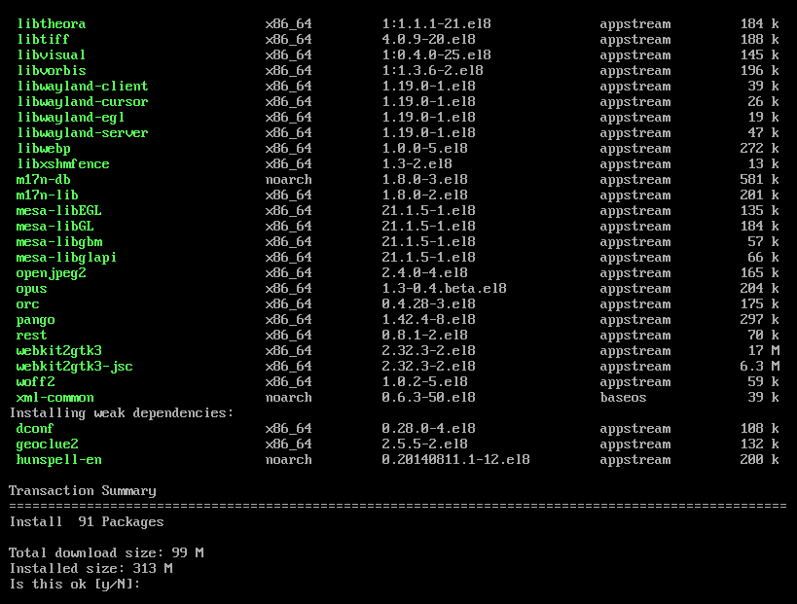

Similar to the above step when asked to install hit y

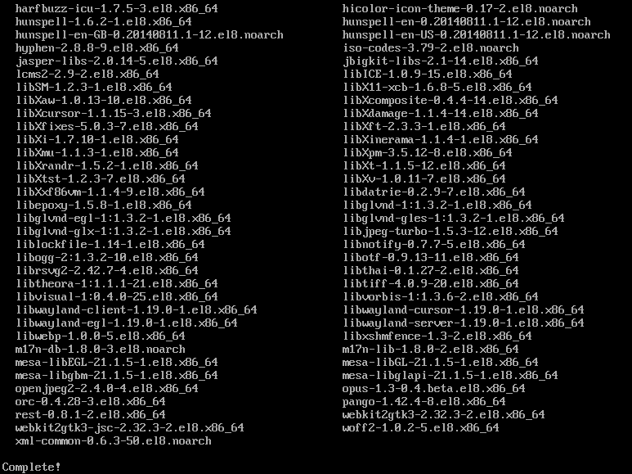

12/5/21

**Fail2ban**

First we need to install a dependency to get fail2ban running type sudo yum Install epel-release

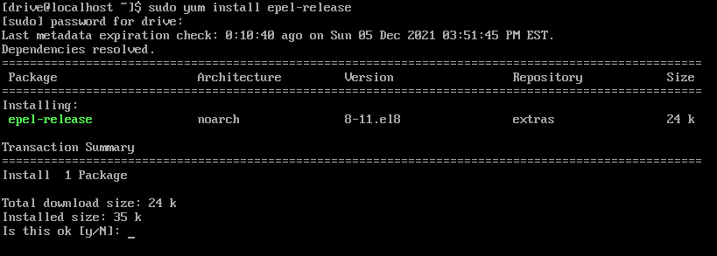

Hit y to install and continue

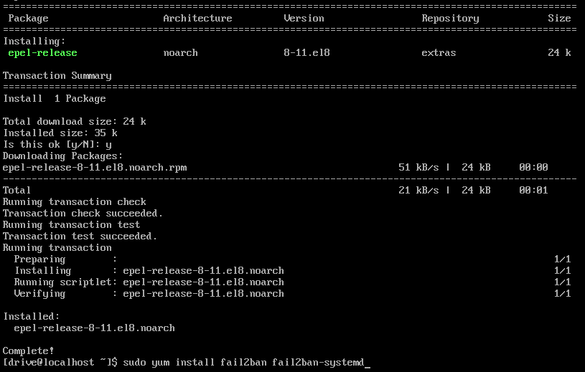

Then to install fail2ban type sudo yum Install fail2ban fail2ban-systemd

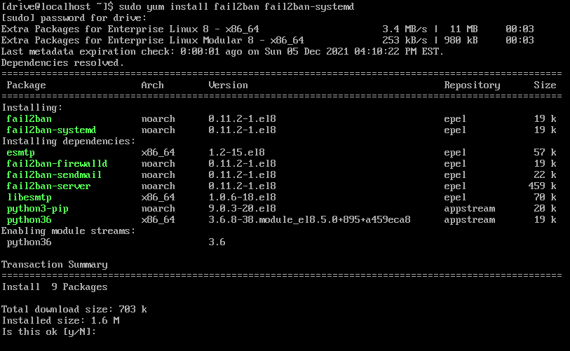

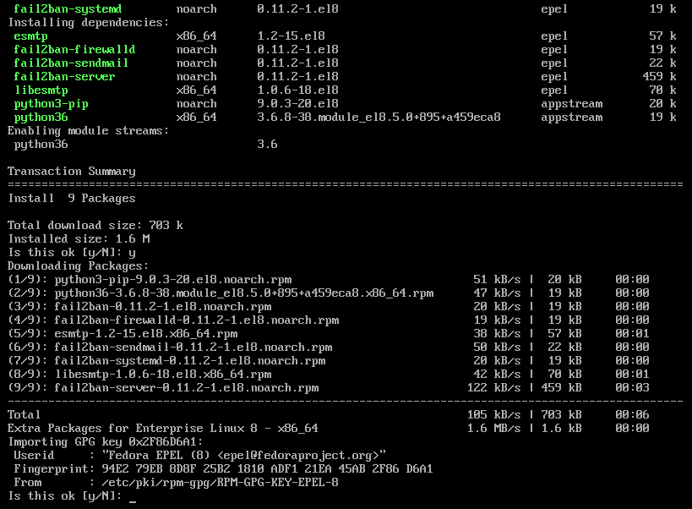

Hit y again to install

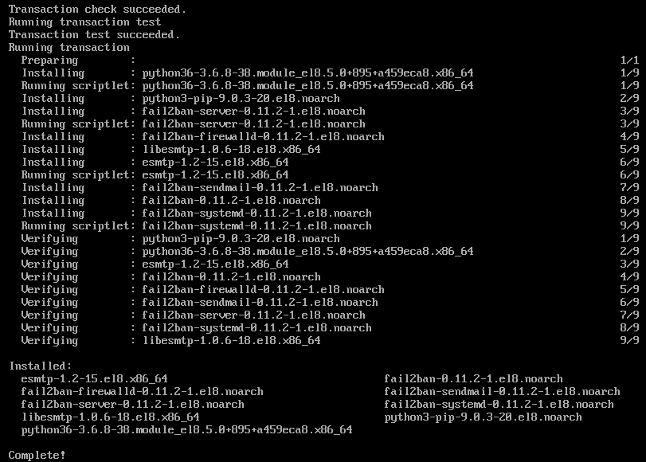

12/5/21

**Cowsay**

To install cowsat type sudo yum Install cowsay

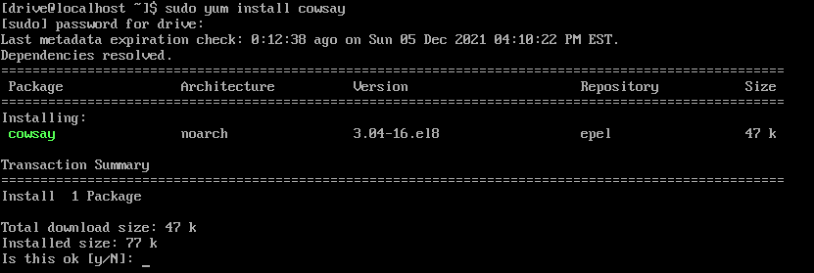

Press y to install

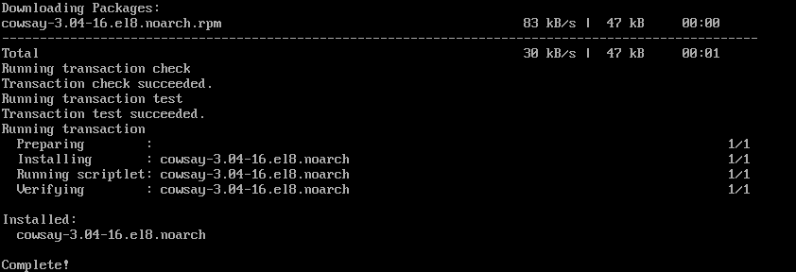12/5/21

**Lolcat**

Similar to fail2ban we need to install a dependency for lolcat type in sudo yum Install ruby

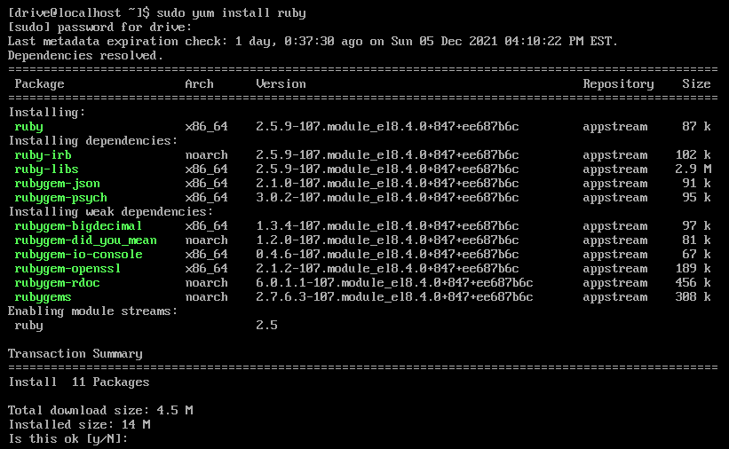

Type y to install

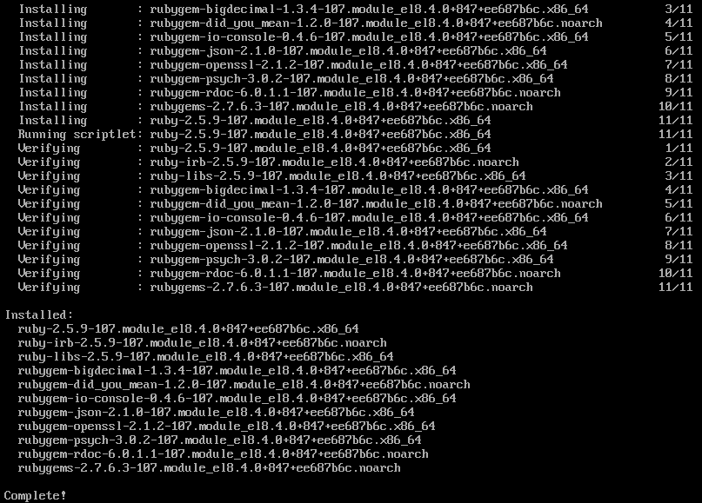

After ruby is installed we need to install a zip file from the github repository we do that by typing wget https://github.com/busyloop/lolcat/archive/master.zip



Once downloaded you should see it says saved at the bottom

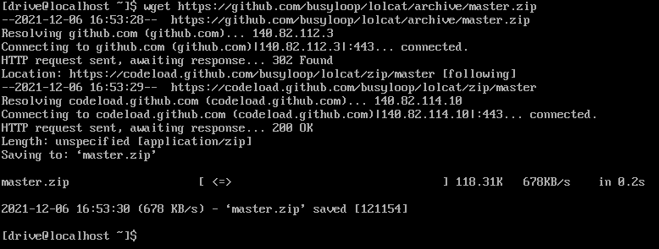

Once saved unzip the file by typping unzip master.zip once finished you’ll need to switch directories into the unzipped file to install lolcat to do so type cd lolcat-master/bin

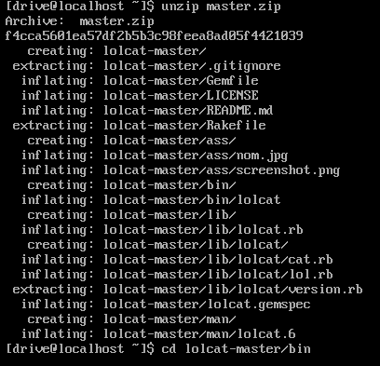

Once in the directory type gem install lolcat to install lolcat

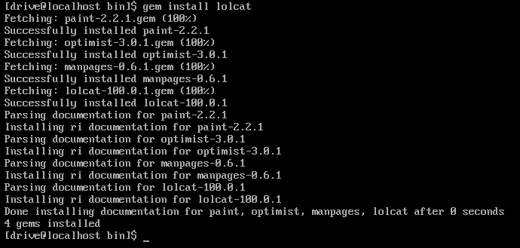

12/5/21

**Vim**

To install the enanced version of vim you need to type sudo yum Install vim-enhanced -y. Since I have it installed already it looks like this but if you don’t hit y to install and you should see complete at the bottom when finished

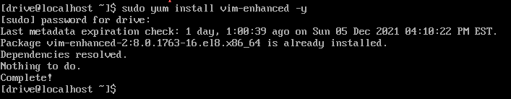

12/5/21

**Ubuntu Server**

To show the repolist in ubuntu you need to type cat /etc/apt/sources.list

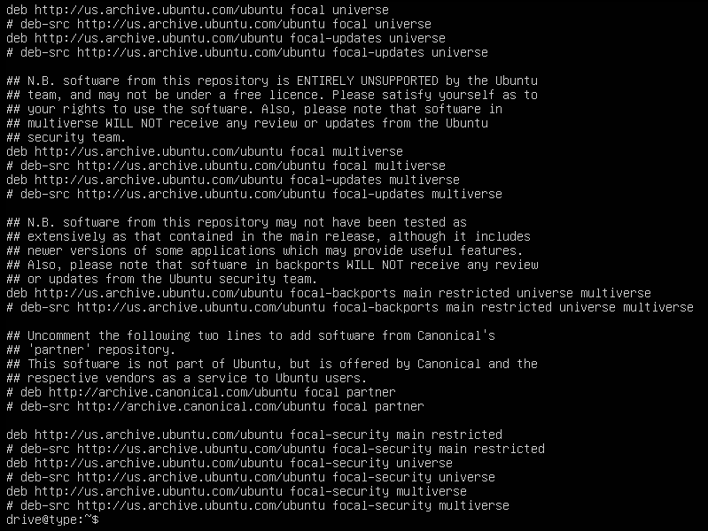

To add a repository in ubuntu you would type in sudo add-apt-repository with the name of the desired application or the github link if you wanted ppa it would look something like this sudo add-apt-repository ppa:jonathonf/ffmpeg-4

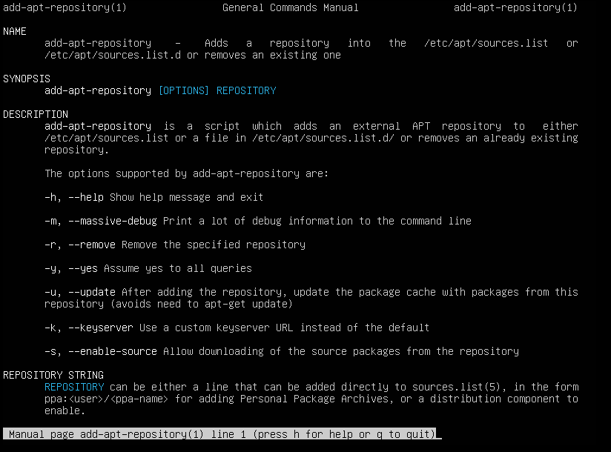

**Tmux**

To install tmux type Sudo apt-get install tmux

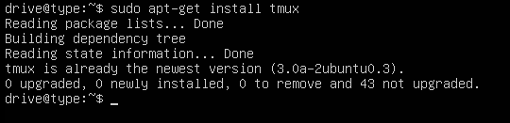

12/6/21

**Emacs**

To install emacs type Sudo apt-get install emacs

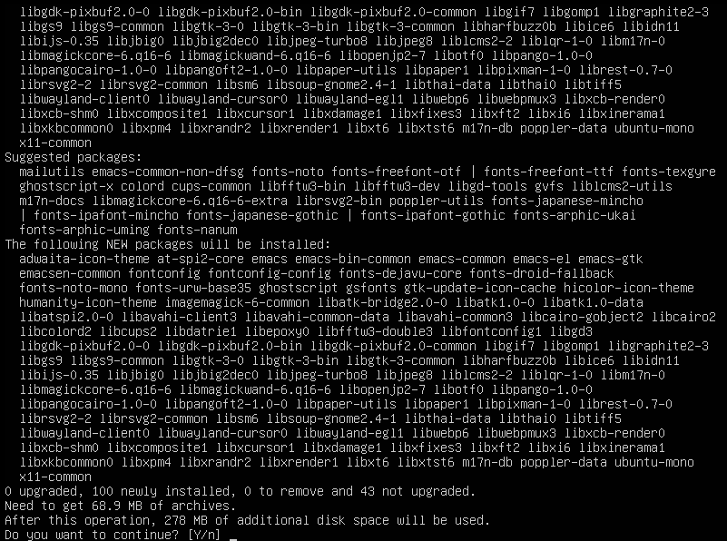

Once done type y to confirm installation of emacs

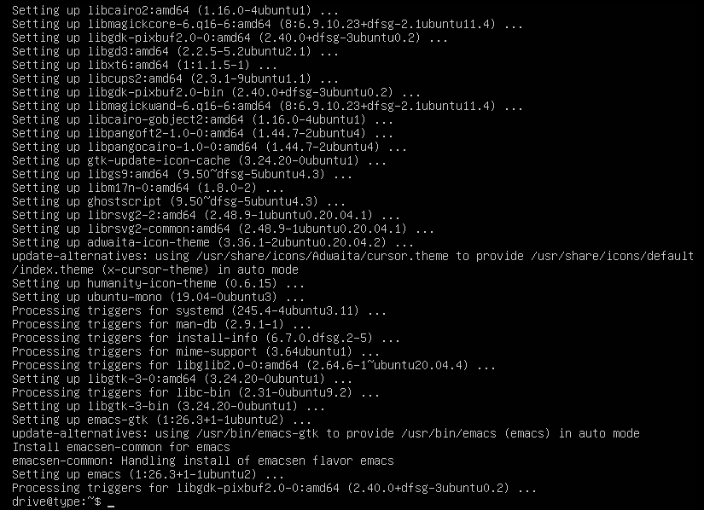

12/6/21

**Fail2ban**

To install fail2ban type Sudo apt-get install fail2ban

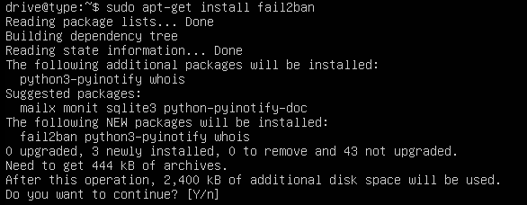

To continue hit y and finish installing

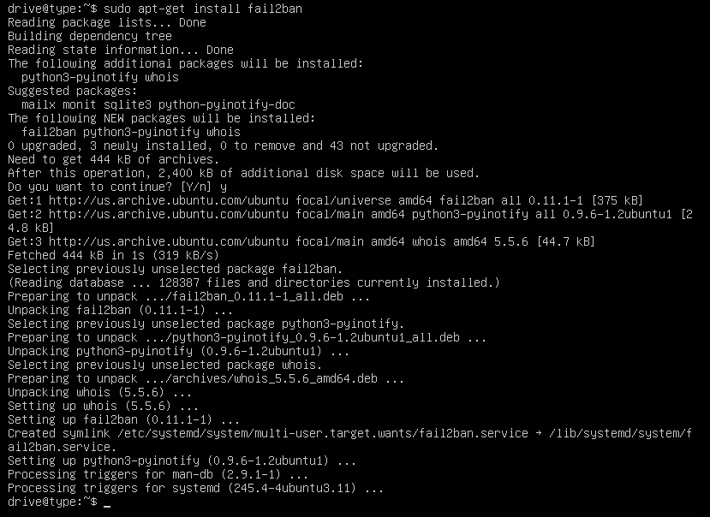

12/6/21

**Cowsay**

To install cowsay type Sudo apt-get install cowsay

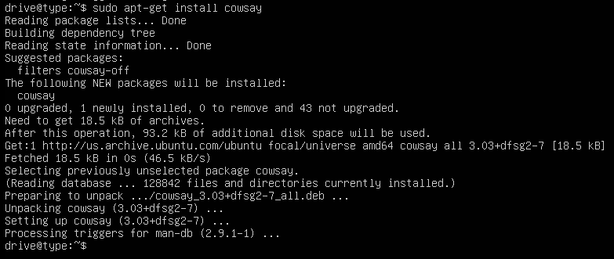

Lolcat-

To install lolcat type Sudo apt-get install lolcat

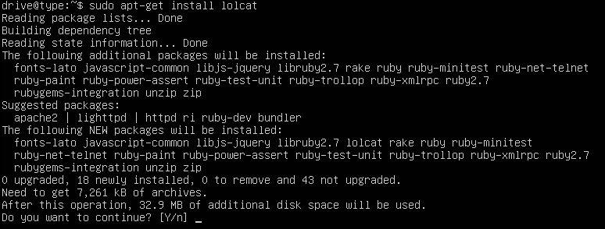

To continue hit y and wait for it to finish

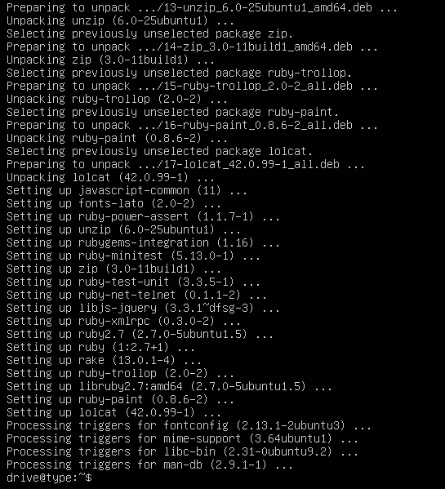

12/6/21

**Vim**

To install vim type Sudo apt-get install vim

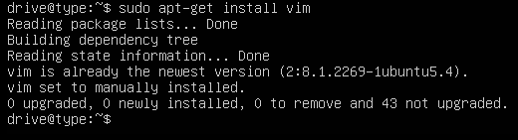

12/6/21

I didn’t make any changes to fail2ban for both servers